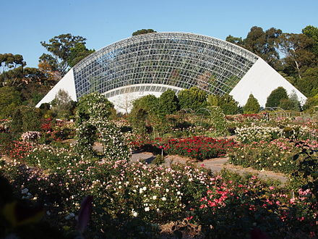

**Biometrics by the Botanic**

**Gardens, Adelaide**

**2-6 December 2019**